Illustration 3—Note Disclosures and Required Supplementary Information for a
Cost-Sharing Employer (No Nonemployer Contributing Entities)

Note: This illustration includes only note disclosures and required supplementary information required by this Statement.

School System XXX (System)
Notes to the Financial Statements for the Fiscal Year Ended September 30, 2019
(Dollar amounts in thousands)

Summary of Significant Accounting Policies

Pensions

The Teachers’ Retirement System of Alabama’s (the Plan or TRS) financial statements are prepared using the economic resources measurement focus and accrual basis of accounting. Contributions are recognized as revenues when earned, pursuant to Plan requirements. Benefits and refunds are recognized when due and payable in accordance with the terms of the Plan. Expenses are recognized when the corresponding liability is incurred, regardless of when the payment is made. Investments are reported at fair value. Financial statements are prepared in accordance with the requirements of the Governmental Accounting Standards Board (GASB). Under these requirements, the Plan is considered a component unit of the State of Alabama and is included in the State’s Comprehensive Annual Financial Report.

Note X

[If the System’s employees were provided with benefits through more than one defined benefit pension plan, the System should disclose information required by paragraph 74 of this Statement and should apply the requirements of paragraph 75 of this Statement.]

General Information about the Pension Plan

Plan Description

The TRS, a cost-sharing multiple-employer public employee retirement plan, was established as of September 15, 1939, pursuant to the Code of Alabama 1975, Title 16, Chapter 25 (Act 419 of the Legislature of 1939) for the purpose of providing retirement allowances and other specified benefits for qualified persons employed by State-supported educational institutions. The responsibility for the general administration and operation of the TRS is vested in its Board of Control which consists of 15 trustees. The plan is administered by the Retirement Systems of Alabama (RSA). The Code of Alabama 1975, Title 16, Chapter 25 grants the authority to establish and amend the benefit terms to the TRS Board of Control. The Plan issues a publicly available financial report that can be obtained at www.rsa-al.gov.

Benefits Provided

State law establishes retirement benefits as well as death and disability benefits and any ad hoc increase in postretirement benefits for the TRS. Benefits for TRS members vest after 10 years of creditable service. TRS members who retire after age 60 with 10 years or more of creditable service or with 25 years of service (regardless of age) are entitled to an annual retirement benefit, payable monthly for life. Service and disability retirement benefits are based on a guaranteed minimum or a formula method, with the member receiving payment under the method that yields the highest monthly benefit. Under the formula method, members of the TRS are allowed 2.0125% of their average final compensation (highest 3 of the last 10 years) for each year of service.

Act 377 of the Legislature of 2012 established a new tier of benefits (Tier 2) for members hired on or after January 1, 2013. Tier 2 TRS members are eligible for retirement after age 62 with 10 years or more of creditable service and are entitled to an annual retirement benefit, payable monthly for life. Service and disability retirement benefits are based on a guaranteed minimum or a formula method, with the member receiving payment under the method that yields the highest monthly benefit. Under the formula method, Tier 2 members of the TRS are allowed 1.65% of their average final compensation (highest 5 of the last 10 years) for each year of service. Members are eligible for disability retirement if they have 10 years of credible service, are currently in-service, and determined by the RSA Medical Board to be permanently incapacitated from further performance of duty. Preretirement death benefits equal to the annual earnable compensation of the member as reported to the Plan for the preceding year ending June 30 are paid to a qualified beneficiary.

Contributions

Covered members of the TRS contributed 5% of earnable compensation to the TRS as required by statute until September 30, 2011. From October 1, 2011, to September 30, 2012, covered members of the TRS were required by statute to contribute 7.25% of earnable compensation. Effective October 1, 2012, covered members of the TRS are required by statute to contribute 7.50% of earnable compensation. Certified law enforcement, correctional officers, and firefighters of the TRS contributed 6% of earnable compensation as required by statute until September 30, 2011. From October 1, 2011, to September 30, 2012, certified law enforcement, correctional officers, and firefighters of the TRS were required by statute to contribute 8.25% of earnable compensation. Effective October 1, 2012, certified law enforcement, correctional officers, and firefighters of the TRS are required by statute to contribute 8.50% of earnable compensation.

Tier 2 covered members of the TRS contribute 6% of earnable compensation to the TRS as required by statute. Tier 2 certified law enforcement, correctional officers, and firefighters of the TRS are required by statute to contribute 7% of earnable compensation.

Participating employers’ contractually required contribution rate for the year ended September 30, 2018, was 12.24% of annual pay for Tier 1 members and 11.01% of annual pay for Tier 2 members. These required contribution rates are a percent of annual payroll, actuarially determined as an amount that, when combined with member contributions, is expected to finance the costs of benefits earned by members during the year, with an additional amount to finance any unfunded accrued liability. Total employer contributions to the pension plan from the System were $[See System general ledger for FY2019] for the year ended September 30, 2019.

Pension Liabilities, Pension Expense, and Deferred Outflows & Inflows of Resources Related to Pensions

At September 30, 2019, the System reported a liability of $[See Detail Report Page 1] for its proportionate share of the collective net pension liability. The collective net pension liability was measured as of September 30, 2018, and the total pension liability used to calculate the net pension liability was determined by an actuarial valuation as of September 30, 2017. The System’s proportion of the collective net pension liability was based on the employers’ shares of contributions to the pension plan relative to the total employer contributions of all participating TRS employers. At September 30, 2018, the System’s proportion was [See Detail Report Page 1] %, which was an increase/(decrease) of [See Detail Report Page 1]% from its proportion measured as of September 30, 2017.

For the year ended September 30, 2019, the System recognized pension expense of $[See System general ledger]. At September 30, 2019, the System reported deferred outflows of resources and deferred inflows of resources related to pensions from the following sources:

*Enter FY2019 employer contributions subsequent to the measurement date for the total of Deferred Outflows of Resources.

$*[FY2019 Employer Contributions subsequent to the measurement date (see amount * above)] reported as deferred outflows of resources related to pensions resulting from System contributions subsequent to the measurement date will be recognized as a reduction of the net pension liability in the year ended September 30, 2020. Other amounts reported as deferred outflows of resources and deferred inflows of resources related to pensions will be recognized in pension expense as follows:

Year ended September 30:
2020 | [See Detail Report Page 1]
2021 | [See Detail Report Page 1]
2022 | [See Detail Report Page 1]
2023 | [See Detail Report Page 1]
2024 | [See Detail Report Page 1}
Thereafter | [See Detail Report Page 1]

Actuarial Assumptions

The total pension liability as of September 30, 2018 was determined by an actuarial valuation as of September 30, 2017, using the following actuarial assumptions, applied to all periods included in the measurement:

The actuarial assumptions used in the actuarial valuation as of September 30, 2017, were based on the results of an investigation of the economic and demographic experience for the TRS based upon participant data as of September 30, 2015. The Board of Control accepted and approved these changes in September 2016 which became effective at the beginning of fiscal year 2016.

Mortality rates for TRS were based on the RP-2000 White Collar Mortality Table projected to 2020 using scale BB and adjusted 115% for males and 112% for females age 78 and older.

The long-term expected rate of return on pension plan investments was determined using a log-normal distribution analysis in which best-estimate ranges of expected future real rates of return (expected returns, net of pension plan investment expense and inflation) are developed for each major asset class. These ranges are combined to produce the long-term expected rate of return by weighting the expected future real rates of return by the target asset allocation percentage and by adding expected inflation. The target asset allocation and best estimates of geometric real rates of return for each major asset class are as follows:

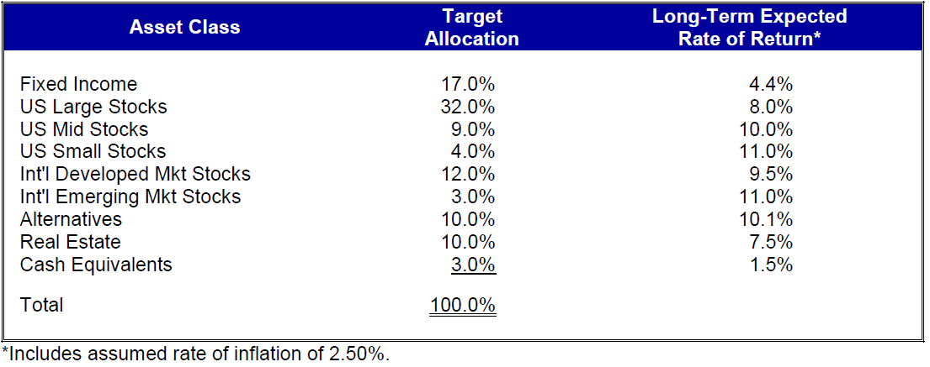

Discount Rate

The discount rate used to measure the total pension liability was 7.70%. The projection of cash flows used to determine the discount rate assumed that plan member contributions will be made at the current contribution rate and that the employer contributions will be made at rates equal to the difference between actuarially determined contribution rates and the member rate. Based on those assumptions, components of the pension plan’s fiduciary net position were projected to be available to make all projected future benefit payments of current pan members. Therefore, the long-term expected rate of return on pension plan investments was applied to all periods of projected benefit payments to determine the total pension liability.

Sensitivity of the System’s Proportionate Share of the Net Pension Liability to Changes in the Discount Rate

The following table presents the System’s proportionate share of the net pension liability calculated using the discount rate of 7.70%, as well as what the System’s proportionate share of the net pension liability would be if it were calculated using a discount rate that is 1-percentage point lower (6.70%) or 1-percentage-point higher (8.70%) than the current rate (dollar amounts in thousands):

Pension Plan Fiduciary Net Position

Detailed information about the pension plan’s fiduciary net position is available in the separately issued RSA Comprehensive Annual Report for the fiscal year ended September 30, 2018. The supporting actuarial information is included in the GASB Statement No. 67 Report for the TRS prepared as of September 30, 2018. The auditor’s report dated August 16, 2019, on the total pension liability, total deferred outflows of resources, total deferred inflows of resources, total pension expense for the sum of all participating entities as of September 30, 2018, along with supporting schedules is also available. The additional financial and actuarial information is available at http://www.rsa-al.gov/index.php/employers/financial-reports/gasb-68-reports/.

Schedules of Required Supplementary Information

